**Chapter 8: AJAX & JSON**

1. When clicking in the button request the page data to the server and produce the following output.

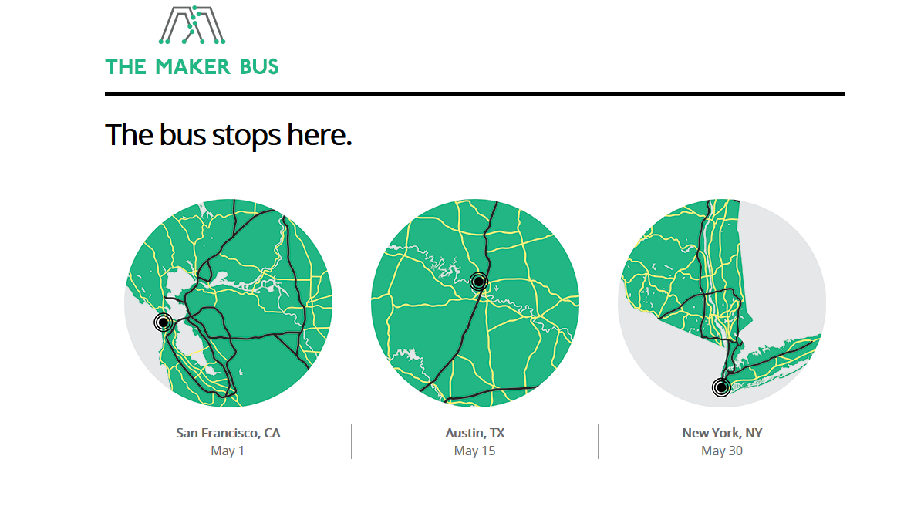

The server response is using the **JSON** format, use the following JSON format:

**[** { "img" :"img/map-ca.png"

,"state" :"California"

,"city" :"San Francisco, CA"

,"date" :"May 1"}

,{ "img" :"img/map-tx.png"

,"state" :"Texas"

,"city" :"Austin, TX"

,"date" :"May 15"}

,{ "img" :"img/map-ny.png"

,"state" :"New York"

,"city" :"New York, NY"

,"date" :"May 30"} **]**;